Dataset 5: Planning Habits & Assignment Completion

Scenario Overview
Students rated their planning habits on a 1–10 scale and teachers recorded the percentage of tasks submitted on time. The scatterplot shows planning score versus on-time submission rate.

Data Summary
Planning score (1–10) | On-time submissions (%)
1 | 55
2 | 70
3 | 60
4 | 75
5 | 65
6 | 78
7 | 68
8 | 82
9 | 66
10 | 80

Figure
Figure 1. Planning score vs on-time submission rate. Pearson’s correlation (r) = 0.72.
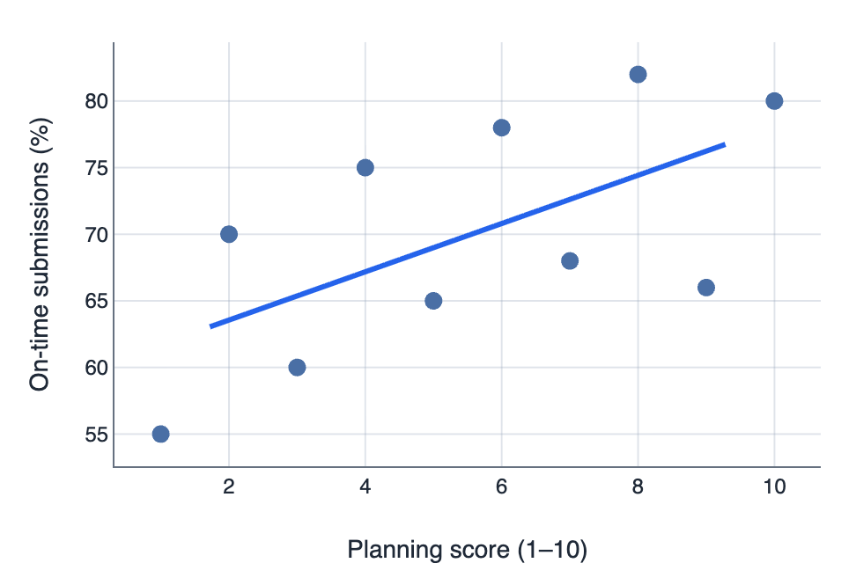

IA1 Practice Questions
- Determine: Using the line of best fit, determine the predicted on-time submission rate for a planning score of 7.

- Calculate: Calculate the mean planning score for the class.

- Identify: Identify the overall pattern and any evidence of a ceiling effect.

- Classify: Classify the strength of the relationship using the r-value provided.

- Infer: Infer one practical implication for study strategy.

- Justify: Justify one possible confounding variable.

